HOSPITAL MANAGEMENT

### Final project for SQL module

#### By Gaurang Sanyasi

#### 1. Description:

The following database schema is designed to function as a comprehensive hospital management system, allowing efficient management of patients, doctors, appointments, admissions, rooms, staff, and billing.

This system aims to streamline the hospital's administrative tasks and provide a smooth experience for both healthcare professionals and patients.

* Enable easy appointment scheduling and personalized patient care.
* Provide a structured appointment booking process for patients and doctors.
* Allocate and track room assignments for patient admissions.
* Enable quick access to patient history, diagnoses, and treatments.

This Database contains 7 tables:

1. Patients
2. Doctors
3. Appointments
4. Staff
5. Rooms
6. Admissions
7. Billing

How these Tables/Entities are related to each other is shown pictorially on the next page through ER Diagram, i.e., Entity Relation Diagram.

### 2. ER-Diagram for Hospital Management:

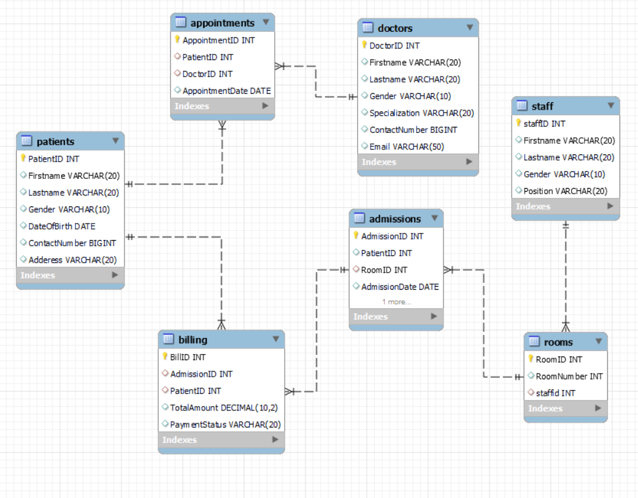

### 3. Table Description:

1. **Patients:**

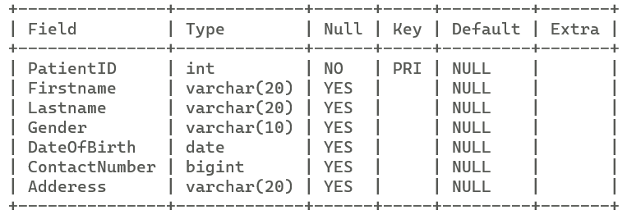

1. **Doctors:**

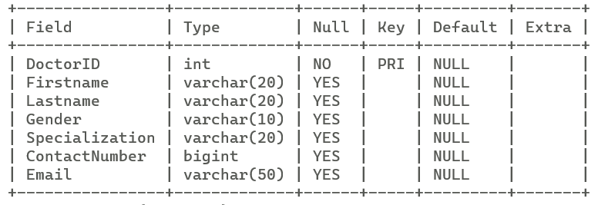

1. **Appointments:**

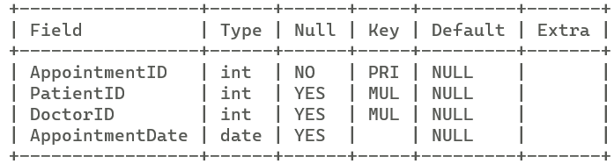

1. **Staff:**

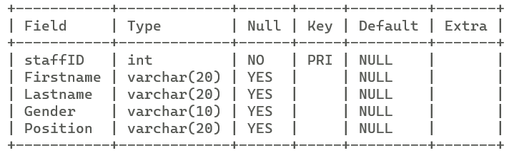

1. **Rooms:**

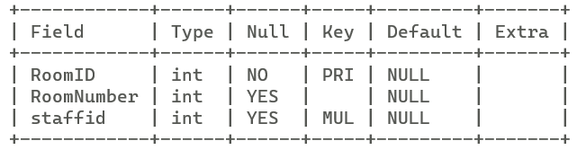

1. **Admissions:**

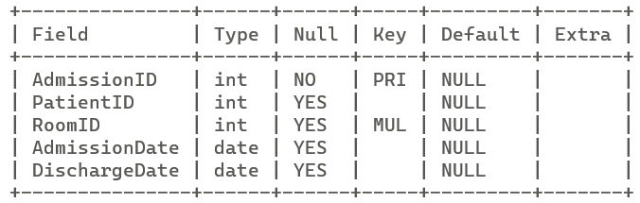

1. **Billing:**

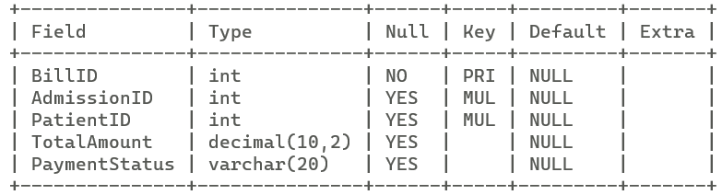

### 4. Commands:

* **Create Database:**

CREATE DATABASE My_Project;

* **Select Database:**

USE My_Project;

* **Create Table named Patients:**

CREATE TABLE Patients (

PatientID INT PRIMARY KEY,

FirstName VARCHAR(50),

LastName VARCHAR(50),

Gender VARCHAR(10),

DateOfBirth DATE,

ContactNumber VARCHAR(15),

Address VARCHAR(100)

);

* **Create Table named Doctors:**

CREATE TABLE Doctors (

DoctorID INT PRIMARY KEY,

FirstName VARCHAR(50),

LastName VARCHAR(50),

Gender VARCHAR(10),

Specialization VARCHAR(50),

ContactNumber VARCHAR(15),

Email VARCHAR(100)

);

* **Create Table named Appointments:**

CREATE TABLE Appointments (

AppointmentID INT PRIMARY KEY,

PatientID INT,

DoctorID INT,

AppointmentDate DATE,

FOREIGN KEY (PatientID) REFERENCES Patients(PatientID),

FOREIGN KEY (DoctorID) REFERENCES Doctors(DoctorID)

);

* **Create Table named Staff:**

CREATE TABLE Staff (

StaffID INT PRIMARY KEY,

FirstName VARCHAR(50),

LastName VARCHAR(50),

Gender VARCHAR(10),

Position VARCHAR(50)

);

* **Create Table named Rooms:**

CREATE TABLE Rooms (

RoomID INT PRIMARY KEY,

RoomNumber VARCHAR(10),

StaffID INT,

FOREIGN KEY (StaffID) REFERENCES Staff(StaffID)

);

* **Create Table named Admissions:**

CREATE TABLE Admissions (

AdmissionID INT PRIMARY KEY,

PatientID INT,

RoomID INT,

AdmissionDate DATE,

DischargeDate DATE,

FOREIGN KEY (PatientID) REFERENCES Patients(PatientID),

FOREIGN KEY (RoomID) REFERENCES Rooms(RoomID)

);

* **Create Table named Billing**

CREATE TABLE Billing (

BillID INT PRIMARY KEY,

AdmissionID INT,

TotalAmount DECIMAL(10, 2),

PaymentStatus VARCHAR(20),

FOREIGN KEY (AdmissionID) REFERENCES Admissions(AdmissionID)

);

* **Populate “Patients” Table**

-> insert into patients

-> values

-> (101, 'John', 'Smith', 'Male', '1990-05-15', 1234567890, '123 Main St,Cityyville'),

-> (102, 'Jane', 'Doe', 'Female', '1985-09-20', 9876543210, '456 Elm St, Townsville'),

-> (103, 'Alex', 'Johnson', 'Male', '1988-03-10', 5551112222, '789 Oak Ave, Villagetown'),

-> (104, 'Emily', 'Williams', 'Female', '1995-12-03', 5555555555, '567 Maple Rd, Countryside'),

-> (105, 'Ryan', 'Turner', 'Male', '1982-11-08', 7778889999, '234 Pine Ln, Meadowville'),

-> (106, 'Olivia', 'White', 'Female', '1998-07-25', 8887776666, '678 Cedar Rd, Hillside'),

-> (107, 'Ethan', 'Harris', 'Male', '2000-02-12', 6665554444, '345 Birch St, Riverside'),

-> (108, 'Ava', 'Martin', 'Female', '1976-09-02', 4443332222, '456 Willow Ave, Lakeside'),

-> (109, 'Liam', 'Lewis', 'Male', '1994-04-18', 2221110000, '567 Oak St, Seaside'),

-> (110, 'Mia', 'Turner', 'Female', '2005-12-30', 1110009999, '679 Elm Ln, Brookside');

* **Populate “Doctors” Table**

-> insert into Doctors

-> values

-> (201, 'Michael', 'Johnson', 'Male', 'Cardiology', 5551234567, 'Michael@Gmail.com'),

-> (202, 'Sarah', 'Williams', 'Female', 'Pediatrics', 5559876543, 'sarah@Gmail.com'),

-> (203, 'David', 'Lee', 'Male', 'Orthopedics', 555-444-3333,'david@Gmail.com'),

-> (204, 'Jessica', 'Miller', 'Female', 'Gynecology', 5557778888, 'jessica@gmail.com'),

-> (205, 'Kevin', 'Brown', 'Male', 'Internal Medicine', 5552229999, 'kevon@gmail.com'),

-> (206, 'Emily', 'Davis', 'Female', 'Dermatology', 5556665555, 'emily@gmail.com'),

-> (207, 'Andrew', 'Wilson', 'Male', 'Neurology', 5555558888, 'Andrew@gmail.com');

* **Populate “Appointments” Table:**

-> insert into Appointments

-> values

-> (301, 101, 201, '2023-08-30'),

-> (302, 102, 202, '2023-09-05'),

-> (303, 103, 203, '2023-09-12'),

-> (304, 104, 204, '2023-08-18'),

-> (305, 101, 205, '2023-09-25'),

-> (306, 105, 206, '2023-10-03'),

-> (307, 106, 207, '2023-10-10'),

-> (308, 107, 201, '2023-10-18');

* **Populate “staff” Table:**

-> insert into staff

-> values

-> (401, 'Emily', 'Davis', 'Female', 'Nurse'),

-> (402, 'Robert', 'Brown', 'Male', 'Receptionist'),

-> (403, 'Maria', 'Martinez', 'Female', 'Nurse'),

-> (404, 'Daniel', 'Clark', 'Male', 'Janitor'),

-> (405, 'Jennifer', 'Adams', 'Female', 'Nurse'),

-> (406, 'William', 'Turner', 'Male', 'Security Guard'),

-> (407, 'Sophia', 'Moore', 'Female', 'Administrator');

* **Populate “Rooms” Table:**

-> insert into rooms

-> values

-> (501, 101, 401),

-> (502, 102, 402),

-> (503, 103, 403),

-> (504, 104, 404),

-> (505, 105, 405),

-> (506, 106, 406),

-> (507, 107, 407),

-> (508, 108, 401),

-> (509, 109, 402),

-> (510, 110, 403);

* **Populate “Admissions” Table:**

-> insert into admissions

-> values

-> (601, 101, 501, '2023-08-28', '2023-09-02'),

-> (602, 102, 502, '2023-09-01', '2023-09-07'),

-> (603, 103, 503, '2023-09-08', '2023-09-15'),

-> (604, 104, 504, '2023-09-14', '2023-09-20'),

-> (605, 105, 505, '2023-09-28', '2023-10-05'),

-> (606, 106, 506, '2023-10-01', '2023-10-08'),

-> (607, 107, 507, '2023-10-09', '2023-10-16'),

-> (608, 108, 508, '2023-10-15', '2023-10-22'),

-> (609, null, 509, null, null),

-> (610, null, 510, null, null);

* **Populate “Billing” Table:**

-> insert into billing

-> values

-> (701, 601, 101, 1500, 'Paid'),

-> (702, 602, 102, 2000, 'Pending'),

-> (703, 603, 103, 1800, 'Paid'),

-> (704, 604, 104, 1600, 'Paid'),

-> (705, 605, 105, 2200, 'Pending'),

-> (706, 606, 106, 2100, 'Paid'),

-> (707, 607, 107, 1900, 'Pending'),

-> (708, 608, 108, 1800, 'Paid');

### 5. Sub-Queries:

1. **List the Names of patients who have appointments scheduled with Dr. Michael Johnson.**

-> SELECT PatientID, Firstname, Lastname, ContactNumber FROM Patients

-> WHERE PatientID IN (SELECT PatientID FROM Appointments

-> WHERE DoctorID = (SELECT DoctorID FROM Doctors

-> WHERE Firstname = 'Michael' AND Lastname = 'Johnson')

-> );

**Result:**

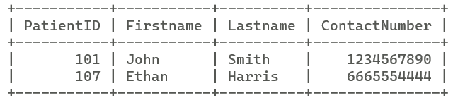

1. **List the patients who have an unpaid bill for their admission.**

-> SELECT P.PatientID, P.Firstname, P.Lastname

-> FROM Patients P

-> WHERE P.PatientID IN (SELECT A.PatientID FROM Admissions A

-> INNER JOIN Billing B ON A.AdmissionID = B.AdmissionID

-> WHERE B.PaymentStatus = 'Pending');

**Result:**

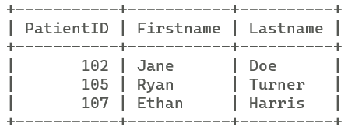

1. **List the names of staff members assigned to rooms.**

-> SELECT FirstName, LastName , StaffID FROM Staff

-> WHERE StaffID IN (SELECT DISTINCT StaffID FROM Rooms);

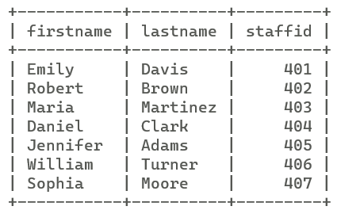

### 6. Joins:

1. **List the patients and their appointments. Include patient names and appointment dates.**

-> SELECT P.FirstName, P.LastName, A.AppointmentDate FROM Patients P

-> INNER JOIN Appointments A ON P.PatientID = A.PatientID;

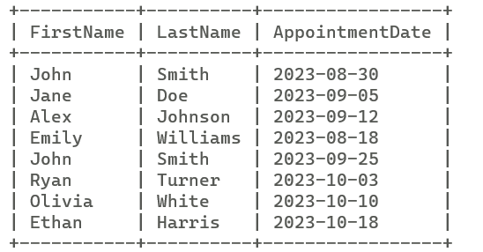

1. **List the staff members and the rooms they are assigned to. Include staff names and room numbers.**

-> SELECT R.RoomNumber, S.FirstName, S.LastName, S.StaffID FROM Rooms R

-> INNER JOIN Staff S ON R.staffid = S.staffID

-> WHERE S.Position = 'Nurse';

